**Name**: Anuj Manoj Shah  
**Roll Number**: 18104B0024  
**Class**: TE  
**Division**: EXTC B  
**Date**: 17-May-2021

**Statement**: Design wire antenna at given frequency (750MHz) for lengths 0.25λ, 0.5λ, 1λ, 1.5λ, and plot its current and impedance.

Matlab Code

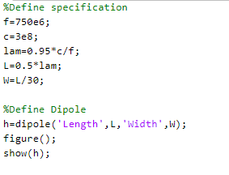

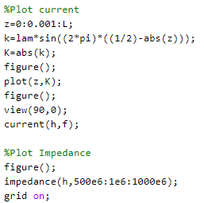

Antenna Structure

0.25λ 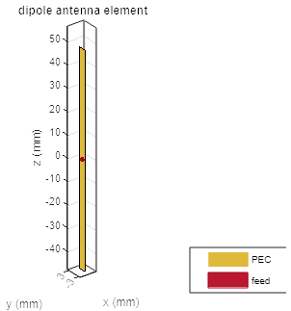 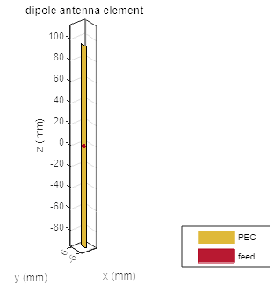0.5λ

1.0λ 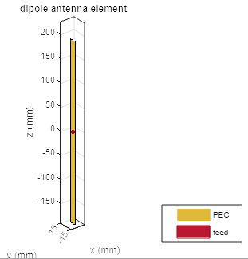 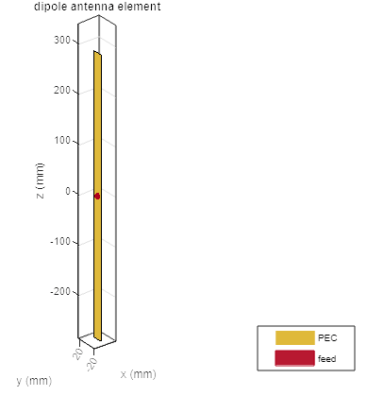 1.5λ

Current Distribution

0.25λ 0.5λ

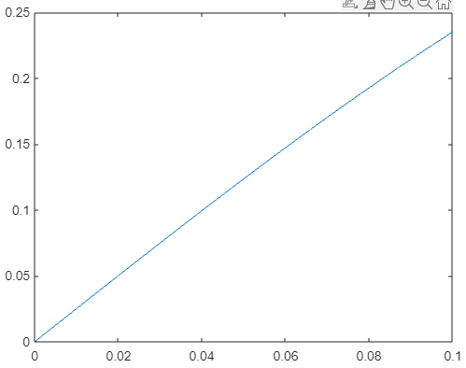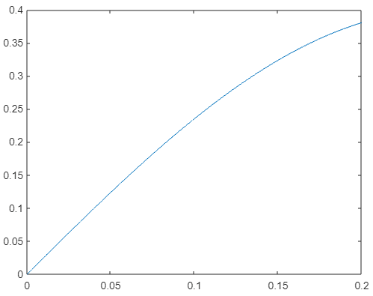

1.0λ 1.5λ

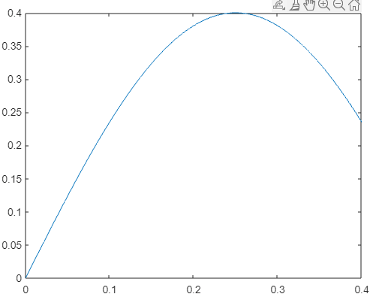 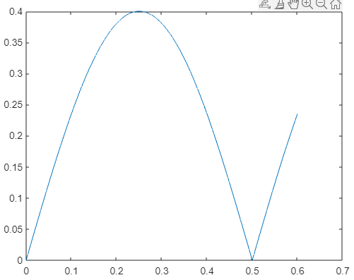

Antenna Impedance

0.25λ 0.5λ

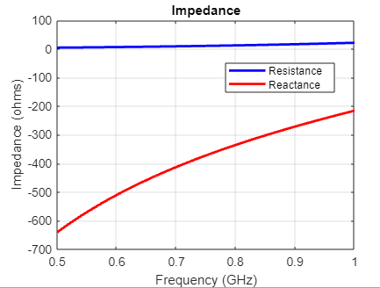 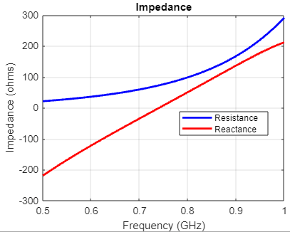

1.0λ 1.5λ

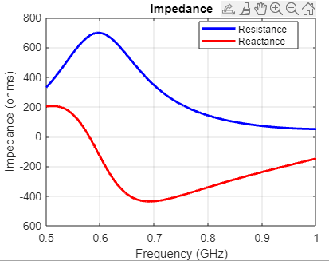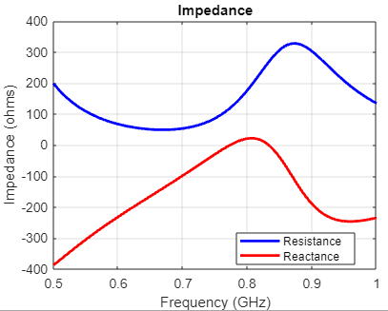

Current Distribution (Bar Chart)

0.25λ 0.5λ

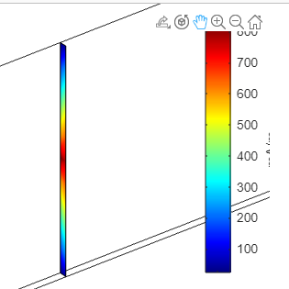 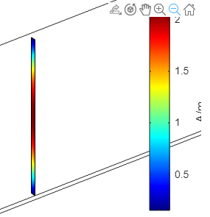

1.0λ 1.5λ

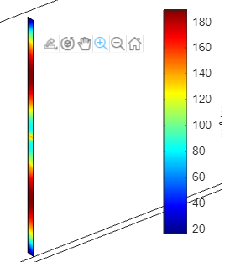 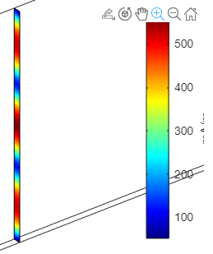

Observations

There is a clear relationship between the length of the antenna and the current distribution:

* dipole length = 0.25λ corresponds to to a 0.25-cycle current distribution
* dipole length = 0.50λ corresponds to to a 0.50-cycle current distribution
* dipole length = 1.00λ corresponds to to a 1.00-cycle current distribution
* dipole length = 1.50λ corresponds to to a 1.50-cycle current distribution

For our antenna to work in the real world, we require two things:

1. close to the signal frequency (f), its resistance ≈ characteristic impedance of the line.
2. close to the signal frequency (f), its reactance ≈ 0.

In the above simulation, f = 750MHz, and characteristic impedance of line = 75Ω. Let's see if the above two conditions are satisfied, using the "Antenna Impedance" graphs:

* dipole length = 0.25λ: resistance = 0. reactance = -350Ω
* dipole length = 0.50λ: resistance = 75Ω. reactance = 0Ω
* dipole length = 1.00λ: resistance = 200Ω. reactance = -400Ω
* dipole length = 1.50λ: resistance = 100Ω. reactance = 0Ω

Thus, we see that the 0.5λ-antenna is perfect for the real world. The 1.5λ-antenna is the second best. The 0.25λ and 1.00λ antennas are bad.

Conclusion

In this experiment, we used MatLab to plot the current and impedance distributions of dipole antennas of various lengths.

We found a clear relationship between dipole length and current distribution.

And we also selected which antenna would work in the real world, based on its impedance distribution.